|  |  |
| --- | --- |
| --2 |  |
| Image Enhancement for selected poor quality images |  |
|  |  |
|  | DSAI 352Mini-Project |
|  | Mohamed Ehab Yousri202201236 |

Image Enhancement for selected poor quality images

[1] Component Extraction from the following images:

Circle Image:

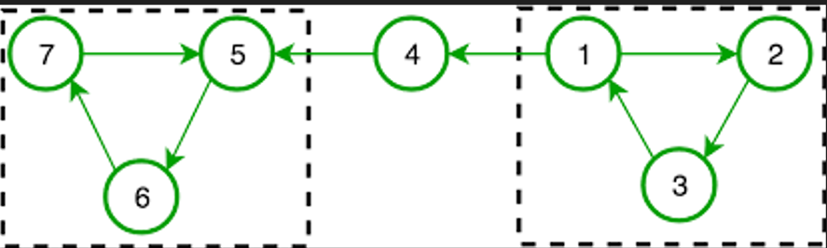

Enhanced Image:

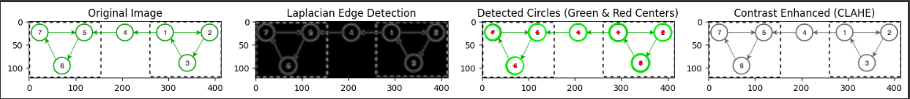

The code applied on the image:

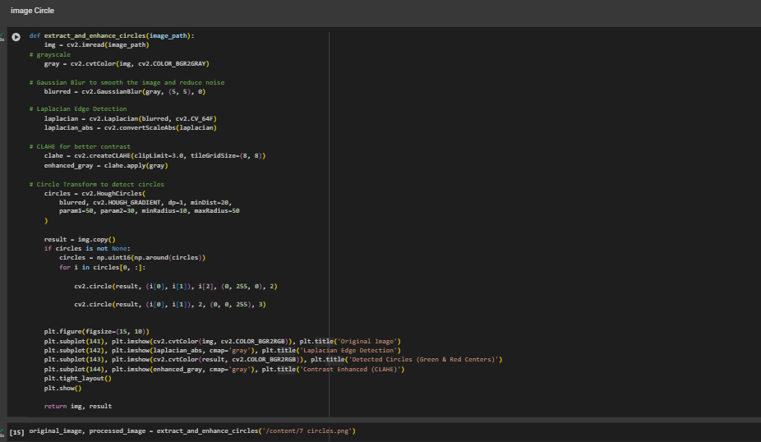

Technique(s) Used to Process the Image and Why to Select This Specific Technique:

For the Circle Image:

-Grayscale Conversion: The first step is converting the image to grayscale. This simplifies the image by eliminating the color information, focusing only on the intensity of the pixels, which is essential for edge detection and circle recognition.

-Gaussian Blur: Gaussian blur is applied to reduce noise in the image. Smoothing the image makes it easier to detect the edges by removing fine details that could interfere with the circle detection.

-Laplacian Edge Detection: The Laplacian filter is used to detect edges in the image. It is sensitive to rapid intensity changes and highlights areas where the edges of the circles are present. This technique is useful in preparing the image for the subsequent Hough Circle Transform.

-CLAHE (Contrast Limited Adaptive Histogram Equalization): CLAHE was used to improve the contrast of the grayscale image. This method is particularly useful for images with uneven lighting, as it enhances local contrast and makes the circular components more visible.

-Hough Circle Transform: This technique detects circles in an image by looking for a combination of edges that form circular shapes. The Hough transform works well when the edges are clear, and the circles are of uniform size.

**Output of Each Technique:**

-Original Image: The raw image, which is the starting point for the processing pipeline.

-Laplacian Edge Detection: The edges in the image are highlighted, showing areas of rapid intensity change, which will help in detecting the circles.

-Detected Circles (Green & Red Centers): Circles are detected using the Hough Circle Transform. The detected circles are highlighted with green borders, and their centers are marked in red.

-Contrast Enhanced (CLAHE): The contrast-enhanced version of the grayscale image, which makes the features more prominent, especially the edges of the circles.

**Discussion of Results:**

**Pros:**

* **Hough Circle Transform**: Effectively detects circles, even with some noise, and can identify their size and center accurately.
* **Laplacian Edge Detection**: Detects sharp intensity changes, helping find the edges of circles.
* **CLAHE**: Enhances contrast, making circles more visible, especially in uneven lighting.

**Cons:**

* **Hough Circle Transform**: May miss faint or distorted circles and sometimes detect false positives.
* **CLAHE**: Can introduce noise or artifacts, especially in noisy images.
* **Laplacian Edge Detection**: Sensitive to noise; improper smoothing can cause incorrect edge detection.

**Quality Achieved:**

The circles are clearly visible, and the contrast enhancement helps make the detection more reliable.

**Failure Reasons:**

Distorted or faint circles may not be detected well by the Hough Transform. Noise can affect edge detection accuracy.

**Suggestions for Future Processing:**

* Use **Canny Edge Detection** before Hough Transform to improve edge detection.
* Experiment with Hough Transform parameters to refine circle detection.
* Consider advanced denoising methods like **Non-Local Means Denoising** for better results.

COVID‐19 Chart Image:



Enhanced Image:

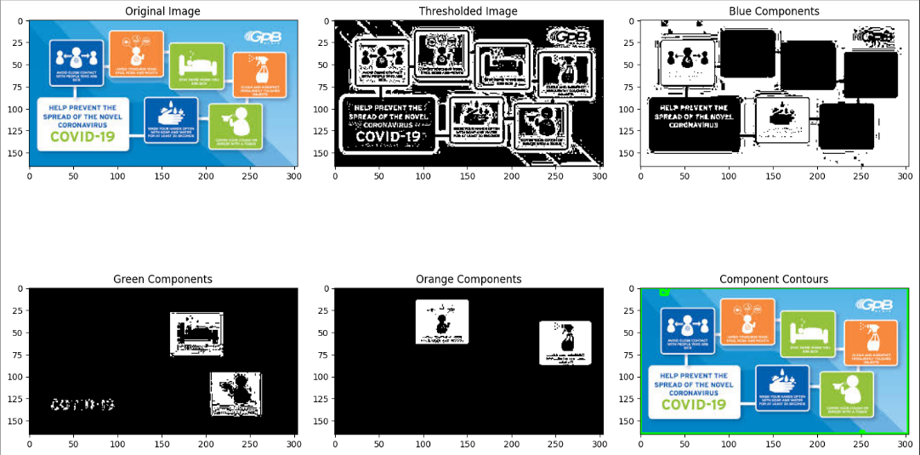

The code applied on the image:

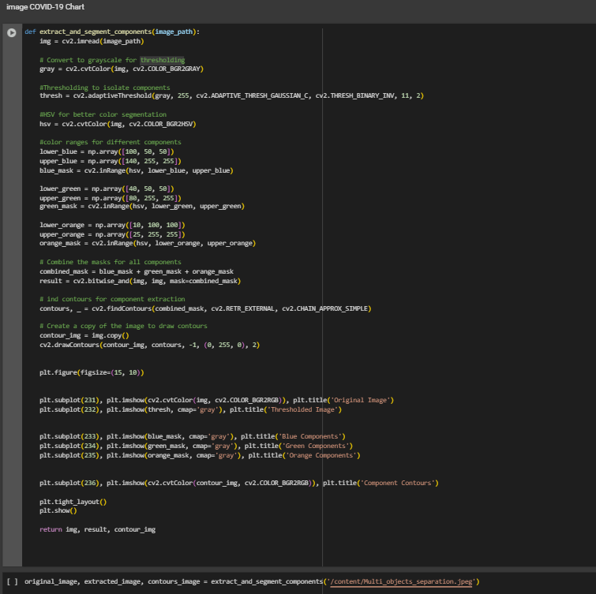

Technique(s) Used to Process the Image and Why to Select This Specific Technique:

-Thresholding (Adaptive Thresholding): This technique was used to isolate the components of the image, separating background from foreground. Adaptive thresholding is useful in handling varying lighting conditions within an image.

-HSV (Color Segmentation): By converting the image to the HSV color space, it was easier to identify and segment components based on specific color ranges (blue, green, orange).

-Contour Detection: After segmenting the image based on color, contours were used to detect the edges of the segmented components.

-Bitwise Operations: These were applied to combine the masks from the different color channels (blue, green, and orange) and extract the desired components.

Output of Each Technique:

-Thresholded Image: This image isolates the foreground components from the background, making it easier to identify the objects.

-Blue, Green, Orange Components: These images show the segmented regions based on specific color masks.

-Component Contours: This image highlights the boundaries of the extracted components, showing the shapes and locations of each identified object.

Discussion of the Results:

**Pros:**

* + **Adaptive Thresholding**: Successfully isolates components even under varying lighting conditions, making objects more visible and easier to detect.
  + **HSV Color Segmentation**: Allows precise color-based component extraction, which is useful when components have distinct colors.
  + **Contours**: Provides a clear visualization of the detected components, helping in visual analysis and understanding of their placement.

**Cons:**

* + **Thresholding**: May struggle if the image contains very faint components or inconsistent lighting.
  + **Color Segmentation**: May not work well if components have overlapping or similar colors.
  + **Contours**: Sometimes results in false contours or incomplete shapes if the segmentation is not precise enough.

**Quality Achieved:**

The technique provided a good quality result, with clearly extracted components and accurate contouring. The color-based segmentation made it easy to isolate and identify individual elements.

**Failure Reasons:**

If the components are too similar in color or if there is excessive noise, the segmentation may fail to distinguish the components accurately. Additionally, if the contrast between components is low, thresholding might not work effectively.

**Suggestions for Future Processing:**

* + Experiment with **Canny Edge Detection** to enhance the edges before performing segmentation.
  + Use **K-means clustering** for a more advanced segmentation technique that can handle more complex images.
  + Improve segmentation accuracy by applying more advanced denoising methods before segmentation.

[2] Enhancement of Blurry Images:

Building Image:

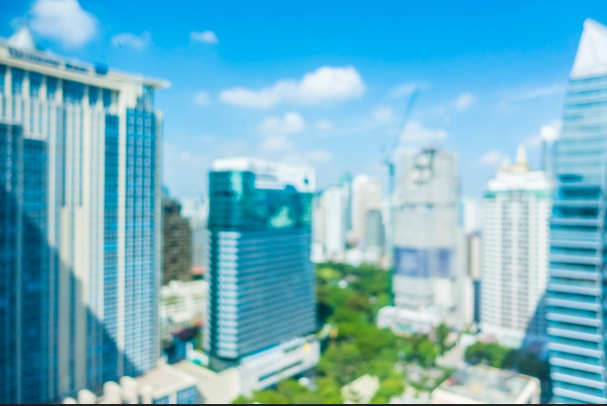

Enhanced Image:

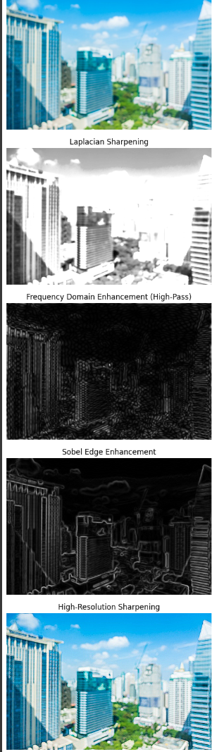

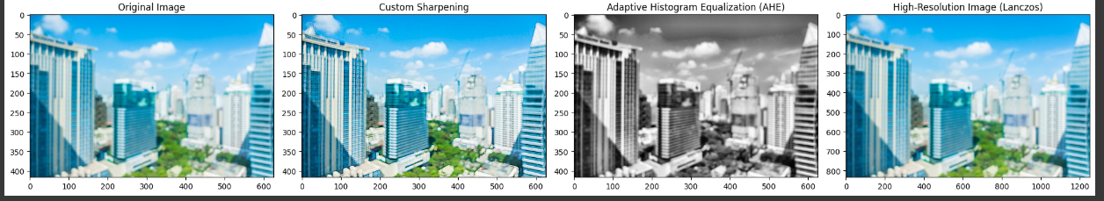

The code applied on the image:

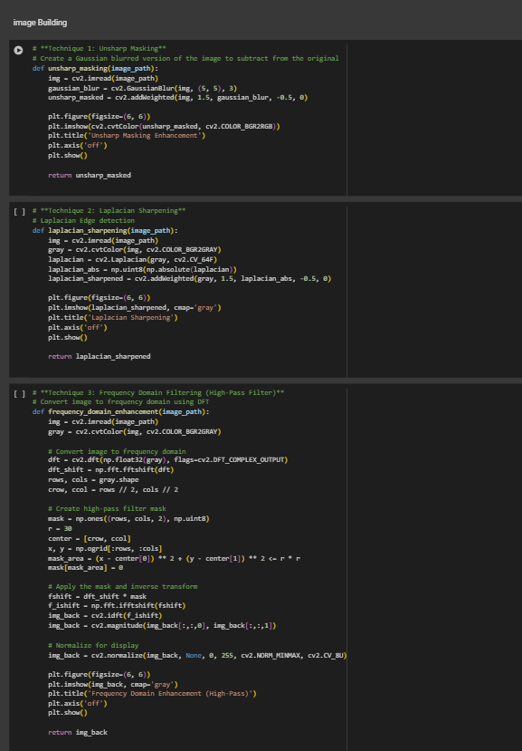

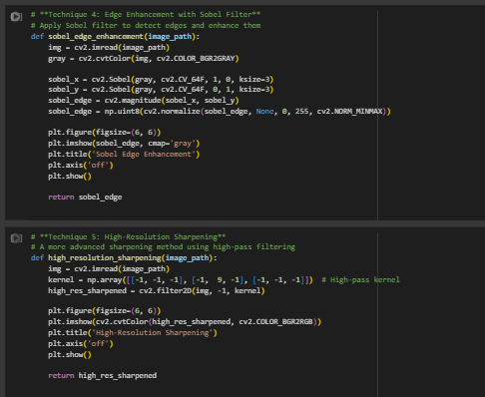

Technique(s) Used to Process the Image and Why to Select This Specific Technique:

-Unsharp Masking: Unsharp masking is a classical method for image sharpening. It works by subtracting a blurred version of the image from the original image, enhancing the edges and details.

Purpose: To enhance the details and edges of the image, making it sharper.

-Laplacian Sharpening: Laplacian edge detection highlights areas of rapid intensity change. When combined with the original image, it sharpens the edges and enhances the contrast in those regions.

Purpose: To enhance the fine details and edges in the image and bring out the structure of the image more clearly.

-Frequency Domain Enhancement (High-Pass Filter): Using a high-pass filter in the frequency domain helps in enhancing high-frequency components of the image, which correspond to sharp edges and fine details.

Purpose: To enhance sharp edges and reduce blurring or low-frequency information that causes softness in the image.

-Sobel Edge Enhancement: Sobel edge detection highlights the edges of objects within the image, which makes the image look more structured and clearer, especially for images with fine details or complex patterns.

Purpose: To accentuate the boundaries and edges within the image.

-High-Resolution Sharpening: A high-pass filter kernel is applied to enhance the high-frequency components of the image. This results in clearer edges and better visual details.

Purpose: To improve the sharpness and overall clarity of the image by enhancing high-frequency details.

Output of Each Technique:

-Unsharp Masking: The edges in the image are sharper, but there may be some noise amplified along with the edges.

-Laplacian Sharpening: More prominent edges and a clear delineation of details. However, some noise may become more visible in the image.

-Frequency Domain Enhancement (High-Pass Filter): Enhanced sharpness of edges, but may cause some artifacts in certain regions.

-Sobel Edge Enhancement: Clear edges and boundaries, but some areas of the image may become overly emphasized, potentially leading to a loss of subtle details.

-High-Resolution Sharpening: Provides the sharpest results in terms of edge enhancement, resulting in a more visually clear and focused image.

**Discussion of the Results:**

**Pros:**

* + **Unsharp Masking:** Simple and effective for sharpening, making the details more prominent.
  + **Laplacian Sharpening:** Great for enhancing sharp features in the image, especially edges.
  + **Frequency Domain Enhancement (High-Pass Filter):** Targets high-frequency components that represent sharpness and details, leading to a clearer image.
  + **Sobel Edge Enhancement:** Ideal for enhancing boundaries and making fine structures more visible.
  + **High-Resolution Sharpening:** Significantly improves the sharpness and clarity of the image, providing the best results among all techniques.

**Cons:**

* + **Unsharp Masking:** Can introduce noise, especially in areas where there is little contrast or detail.
  + **Laplacian Sharpening:** Sensitive to noise; excessive sharpening may result in artifacts and an unnatural look.
  + **Frequency Domain Enhancement (High-Pass Filter):** Can result in unnatural visual artifacts if not applied correctly.
  + **Sobel Edge Enhancement:** Some edges may become exaggerated, which may make the image look more artificial.
  + **High-Resolution Sharpening:** May sometimes introduce minor artifacts in areas with low contrast, but generally provides the best result for sharpening.

**Quality Achieved:** The techniques collectively provided an enhanced sharpness, making edges clearer and improving the overall focus of the image. The sharpness is especially improved with the High-Resolution Sharpening technique.

**Failure Reasons:** If the image contains significant noise or blurring, the sharpening techniques, especially Unsharp Masking, may cause the noise to become more apparent.

-If the edge detection methods like Sobel and Laplacian are not properly applied, they may produce excessive artifacts, especially on areas with subtle details.

**Suggestions for Future Processing:**

* + **Advanced Denoising:** Use more sophisticated denoising techniques like Non-Local Means Denoising before applying edge enhancement or sharpening techniques.
  + **Optimizing Parameters:** Fine-tune the parameters in edge detection methods (like Sobel or Laplacian) to minimize artifacts and preserve fine details.
  + **Try Hybrid Approaches:** Combine methods, such as first using a low-pass filter followed by high-pass filtering to refine sharpness.

Dog Image:

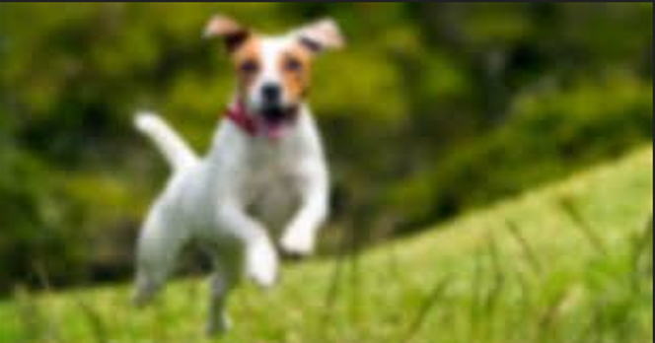

Enhanced Image:

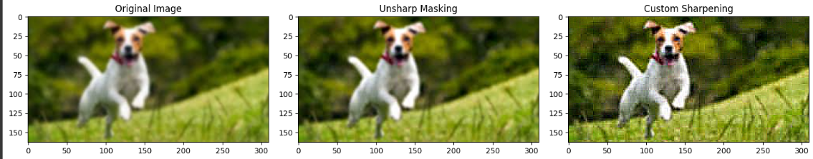

The code applied on the image:

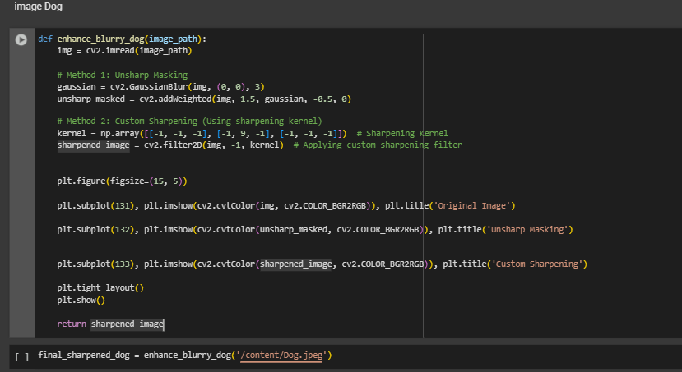

Technique(s) Used to Process the Image and Why to Select This Specific Technique:

-**Unsharp Masking:** Unsharp masking works by subtracting a blurred version of the image from the original, which highlights the edges and fine details of the image.

**Purpose:** To enhance the sharpness of the image and make the details more prominent.

**-Custom Sharpening (Using Sharpening Kernel):**This technique uses a convolutional kernel to emphasize edges and sharp transitions, making the image clearer and more defined.

**Purpose:** To achieve finer sharpening and enhance edges within the image.

**Output of Each Technique:**

**-Unsharp Masking:** The image becomes sharper with enhanced edges. However, some noise may also be accentuated, making the image appear slightly grainy in certain areas.

**-Custom Sharpening:** The edges become more defined, and overall sharpness increases. The details of the dog and background are clearer, but the image can appear slightly over-sharpened.

**Discussion of the Results:**

**Pros:**

* + **Unsharp Masking:** Very effective at enhancing edges and details. It’s a simple yet powerful sharpening method.
  + **Custom Sharpening:** More controlled sharpening with the use of a kernel, allowing for better definition of edges and contrast enhancement in specific parts of the image.

**Cons:**

* + **Unsharp Masking:** While it sharpens the image, it can also amplify noise, especially in regions with low contrast or smooth areas.
  + **Custom Sharpening:** It can result in halo effects or over-sharpening, which may make the image appear artificial.

**Quality Achieved:**

* + Both techniques provided an improved sharpness, with Custom Sharpening giving slightly more detailed edges and clearer structure. However, the final image might feel too sharp in areas with fine textures or smooth regions.

**Failure Reasons:**

* + If the image is too noisy or has too much blur, both techniques might not provide the best results and can highlight unwanted noise or artifacts.
  + For images with soft edges or low contrast, sharpening might fail to produce satisfactory results.

**Suggestions for Future Processing:**

* + **Denoising:** Implementing a denoising technique like Non-Local Means Denoising before applying sharpening could significantly improve the result, especially for images with visible noise.
  + **Edge Detection:** Trying edge detection methods like Canny Edge Detection before sharpening could help preserve the natural look while enhancing edges.

[3] Noise removal from Noisy Images:

Text Image:

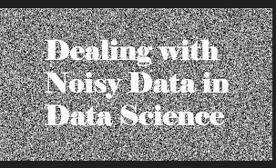

Enhanced Image:

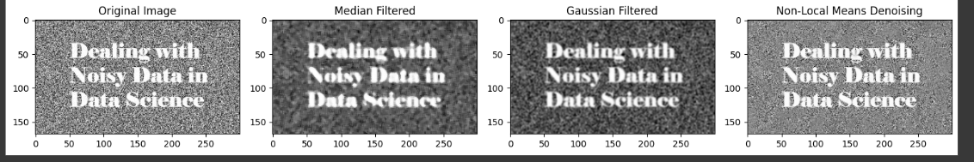

Rocket Image:

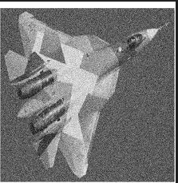

Enhanced Image:

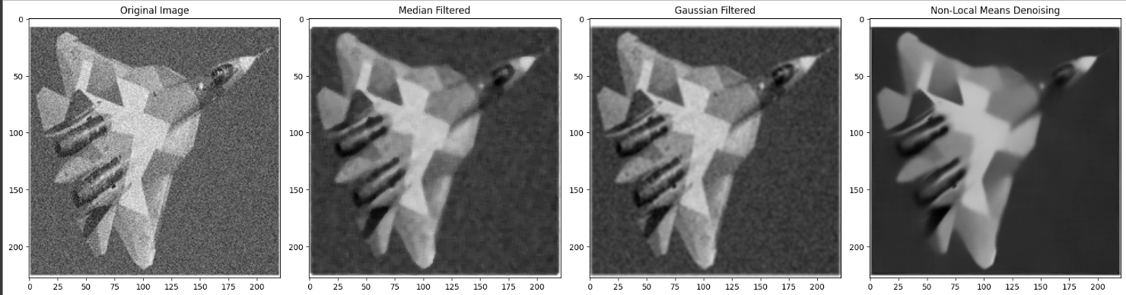

Wind Chart Image:

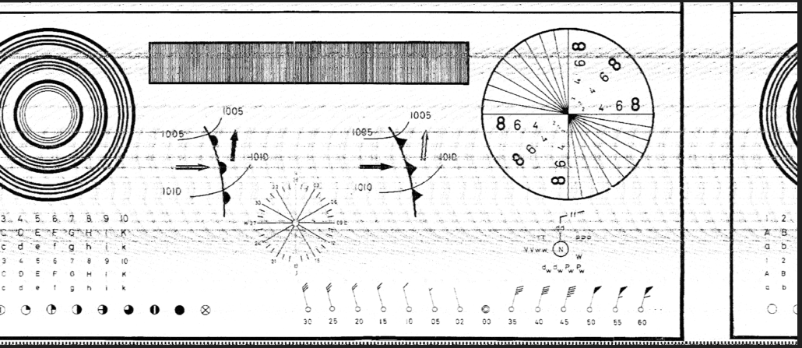

Enhanced Image:

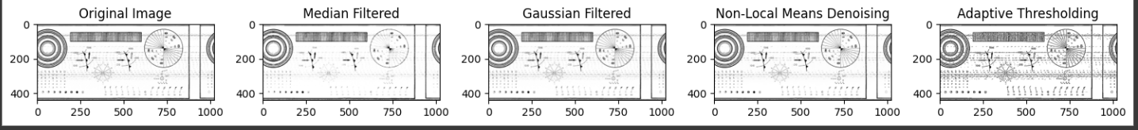

The code applied on the images:

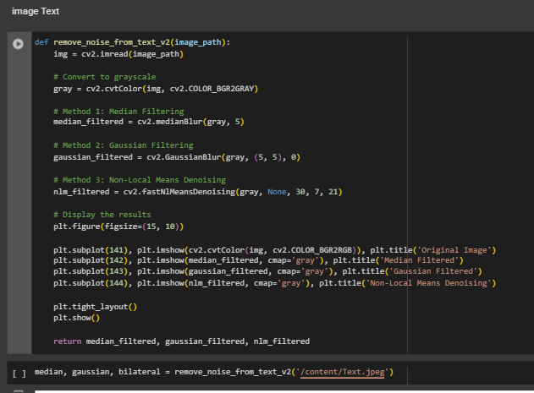

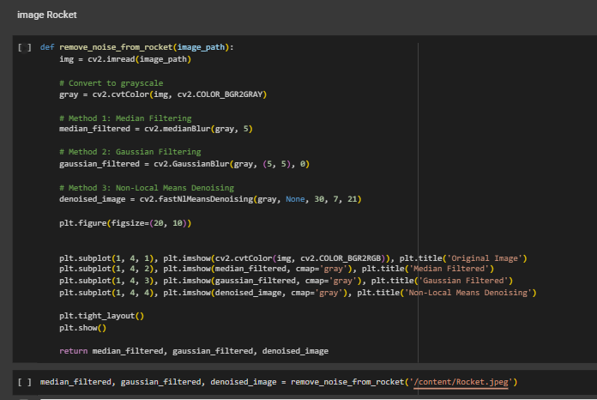

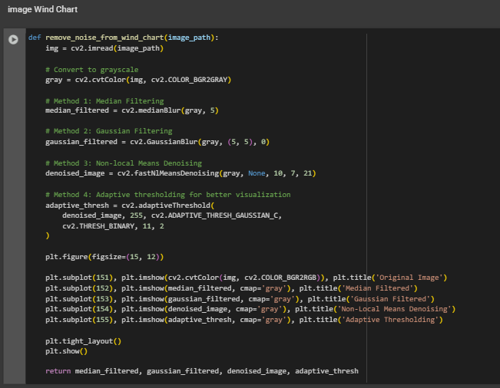

Technique(s) Used to Process the Image and Why to Select This Specific Technique:

-Median Filtering: A non-linear filter used for noise reduction, particularly effective for salt-and-pepper noise.

-Gaussian Filtering: A linear filter used to reduce Gaussian noise. It smooths the image by averaging pixel values in a Gaussian distribution.

-Non-Local Means Denoising: A more advanced denoising technique that considers the similarity of patches in the image.

-Adaptive Thresholding: Specifically used for the Wind Chart image, adaptive thresholding helps in enhancing features by thresholding pixel values based on their local neighborhood.

#### **Output for Each Technique**:

1. **Text Image**:
   * **Median Filtered**: Reduced noise while preserving text integrity.
   * **Gaussian Filtered**: Smoothed the image, but may have blurred some text.
   * **Non-Local Means Denoising**: Removed noise effectively without losing much detail.
2. **Rocket Image**:
   * **Median Filtered**: Effective for removing noise but a slight blurring was observed.
   * **Gaussian Filtered**: Reduced noise significantly but softened some features.
   * **Non-Local Means Denoising**: Produced the cleanest image with minimal loss of detail.
3. **Wind Chart Image**:
   * **Median Filtered**: Cleaned the noise around the chart’s components but didn't fully preserve sharp edges.
   * **Gaussian Filtered**: More smoothing compared to median filtering.
   * **Non-Local Means Denoising**: Very effective in denoising while preserving component details.
   * **Adaptive Thresholding**: Enhanced the visibility of components and features by converting them to binary, making them stand out clearly.

**Discussion of Results:**

**-Pros**:

* + **Median Filtering**: Simple and effective for salt-and-pepper noise but may blur edges.
  + **Gaussian Filtering**: Useful for smoothing out Gaussian noise, works well for images with light noise.
  + **Non-Local Means Denoising**: Excellent for complex noise patterns and preserving image details.
  + **Adaptive Thresholding**: Helps in extracting distinctly, especially for images with well-defined boundaries.

-**Cons**:

* + **Median Filtering**: May introduce slight blurring on edges, especially for high-frequency components.
  + **Gaussian Filtering**: Might blur fine details along with reducing noise.
  + **Non-Local Means Denoising**: Computationally intensive for large images.
  + **Adaptive Thresholding**: Might lead to over-enhancement or loss of finer details in some images.

**-Quality Achieved**: The denoising methods worked well on all images, especially Non-Local Means Denoising. Adaptive thresholding improved the visibility of components in images like the Wind Chart.

**-Failure Reasons**: If noise is too strong or if components are faint, some methods (like Median Filtering) may fail to preserve sharp details.

**-Suggestions for Future Processing**: For more complex images, incorporating a combination of the methods above might yield better results. Experience with advanced methods like bilateral filtering or wavelet denoising for more challenging images.

[4] Visual enhancement of the following images (Challenging Images):

Newspaper Image:

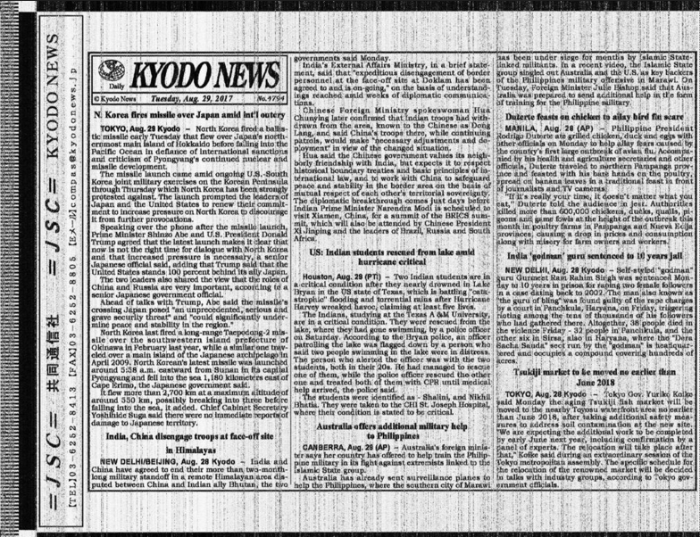

Enhanced Image:

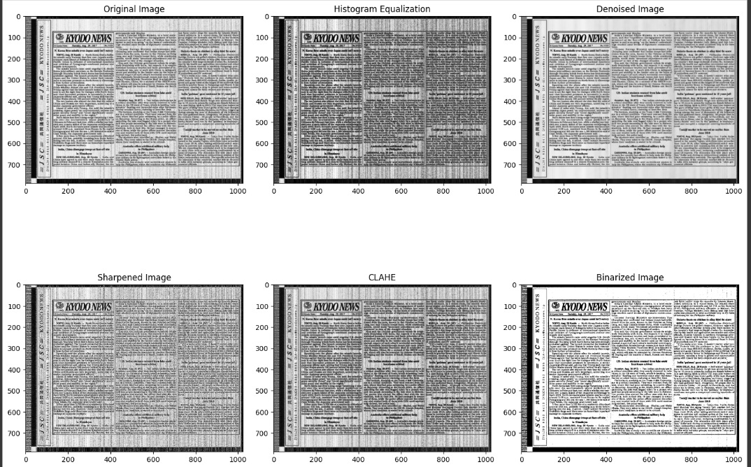

The code applied on the image:

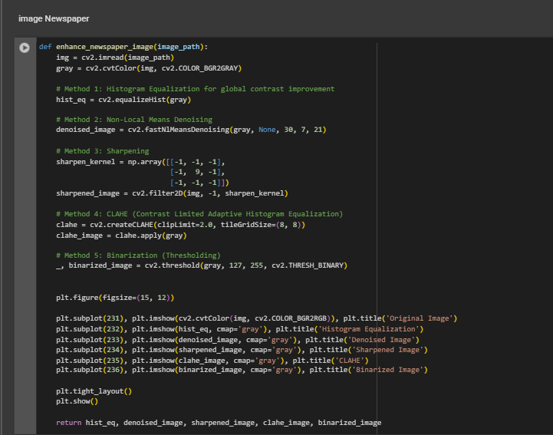

Technique(s) Used to Process the Image and Why to Select This Specific Technique:

-Histogram Equalization: This technique is used for global contrast improvement. It enhances the contrast in the image, making details in darker or lighter areas more visible, which is beneficial when working with images having poor contrast.

-Non-Local Means Denoising: This method is used to reduce noise while preserving the details in the image. It is particularly effective for images that have a significant amount of grainy noise.

-Sharpening (Using Custom Sharpening Kernel): A sharpening kernel is used to enhance the edges in the image. This is particularly useful when the image is blurred and needs to highlight finer details or object boundaries.

-CLAHE (Contrast Limited Adaptive Histogram Equalization): CLAHE improves the contrast locally in different regions of the image, which is effective in areas with poor illumination.

-Binarization (Thresholding): Binarization converts the grayscale image to black and white, which is helpful for extracting text and simple structures from the image.

**Output of Each Technique:**

1. **Histogram Equalization:** This method enhances the contrast in the image, especially useful in regions where the details were previously hard to distinguish.
2. **Non-Local Means Denoising:** The denoised image shows less noise while preserving the details of the text, making it clearer and more readable.
3. **Sharpened Image:** The sharpened image has better-defined edges, helping in reading the text and recognizing details that were blurry before.
4. **CLAHE:** CLAHE enhances the image's local contrast, making it easier to distinguish finer details, particularly in unevenly lit regions.
5. **Binarized Image:**The binarization clearly separates the text from the background, making the text stand out and making the image suitable for optical character recognition (OCR).

**Discussion of the Results:**

**-Pros:**

* + **Histogram Equalization**: It works well for improving the contrast of an image, allowing for more visible details, especially in darker or brighter areas.
  + **Non-Local Means Denoising**: It efficiently reduces noise without blurring the details, which is crucial when the image has a lot of grainy noise.
  + **Sharpening**: It significantly enhances the edges, making the text more readable and helping to bring out the details.
  + **CLAHE**: This technique is particularly useful for images with uneven lighting, as it enhances the local contrast in different regions.
  + **Binarization**: The thresholding process clearly distinguishes text from the background, making it ideal for text extraction or OCR.

**-Cons:**

* + **Histogram Equalization**: While effective in enhancing contrast, it can sometimes make the image appear overly bright or dark in certain regions.
  + **Non-Local Means Denoising**: While it reduces noise, it can sometimes blur fine details if the denoising parameter is too high.
  + **Sharpening**: Over-sharpening may introduce artifacts, especially around edges, resulting in unnatural-looking images.
  + **CLAHE**: In some cases, CLAHE can cause small artifacts in the image, particularly in areas with subtle color transitions.
  + **Binarization**: Binarization may remove important details in some cases, especially if the thresholding value is not set correctly.

**-Quality Achieved:** The combination of these techniques greatly improves the quality of the image, particularly in enhancing text readability and reducing noise. The binarized image stands out as the most useful for extracting text due to its clear contrast between text and background.

**-Failure Reasons:** If the image has very faint or distorted text, some techniques like binarization may fail to detect the text clearly. The quality of the results may also be affected by the image's original quality, such as noise levels and contrast.

**-Suggestions for Future Processing:**

* + Consider adjusting the parameters in the **Non-Local Means Denoising** to better handle different levels of noise.
  + Experiment with **adaptive thresholding** or **OCR-friendly methods** to handle more complex images.
  + Fine-tuning the **Sharpening kernel** and **CLAHE** settings can help in optimizing the image for specific features like text clarity or edge enhancement.

Name Plate Image:

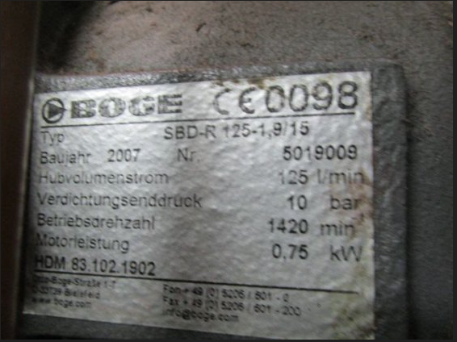

Enhanced Image:

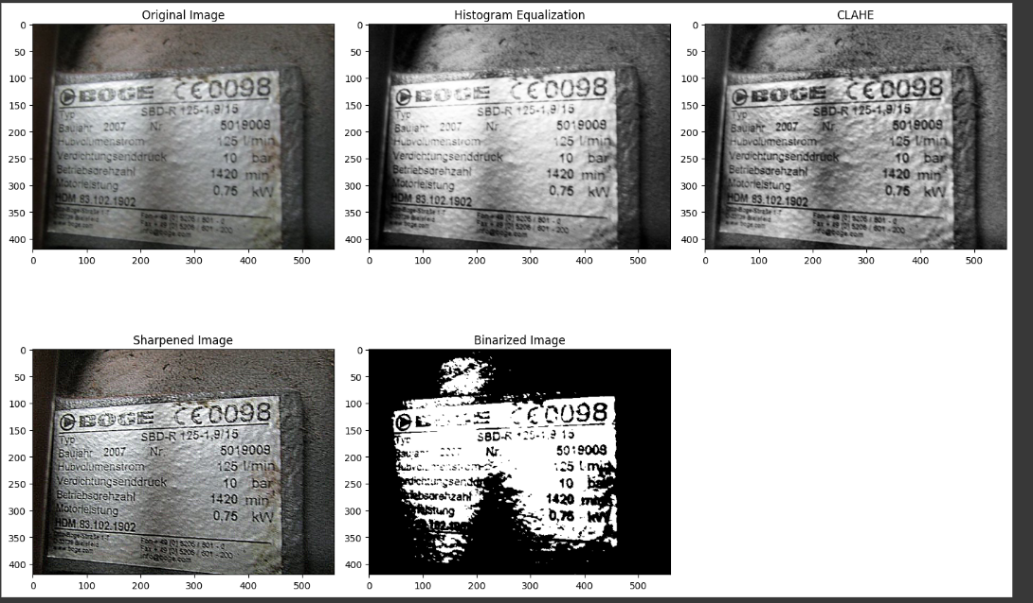

The code applied on the image:

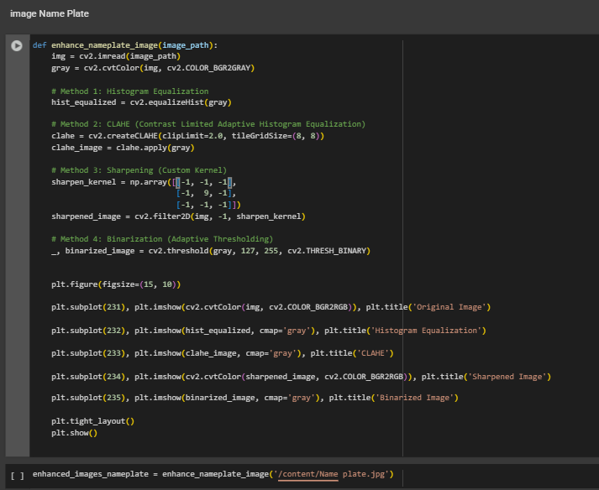

Technique(s) Used to Process the Image and Why to Select This Specific Technique:

-Histogram Equalization: This technique was used to improve the global contrast of the image. It makes the image clearer by enhancing the details that were not visible in the original image due to low contrast.

-CLAHE (Contrast Limited Adaptive Histogram Equalization): CLAHE is used to enhance local contrast in the image. Unlike global contrast enhancement, CLAHE works on smaller regions of the image, making it useful for improving uneven lighting and detail in various parts of the image.

-Sharpening (Custom Sharpening Kernel):The custom sharpening kernel is used to enhance the edges in the image. This is particularly useful for improving the clarity of text and details, making them stand out better.

-Binarization (Thresholding): Binarization is applied to convert the image into black and white, making it easier to extract key components like text or simple shapes from the image.

**Output of Each Technique:**

1. **Histogram Equalization:** This method improves the overall contrast, particularly making dark areas more visible, which can help in distinguishing the text and details from the background.
2. **CLAHE:** CLAHE improves the contrast locally, enhancing areas that were darker or had uneven lighting. This can bring out text and finer details that are hard to distinguish with the original image.
3. **Sharpened Image:** The sharpened image clearly defines the edges of the text and the details, making the content much clearer and more readable.
4. **Binarized Image:** The binarized image converts the grayscale image into pure black and white, which makes the text stand out from the background, making it ideal for OCR (Optical Character Recognition) or simple text extraction.

**Discussion of the Results:**

**-Pros:**

* + **Histogram Equalization:** It effectively enhances the global contrast, making both dark and light areas of the image more visible.
  + **CLAHE:** This method allows for better local contrast improvement, especially in areas with poor illumination or shadows.
  + **Sharpening:** It makes the edges of the text and components much clearer, enhancing visibility.
  + **Binarization:** This technique works well for isolating the text from the background, making it highly suitable for text recognition.

**-Cons:**

* + **Histogram Equalization:** In some cases, it may create overly bright or dark regions, leading to loss of details in those areas.
  + **CLAHE:** While effective for local contrast enhancement, it may introduce some artifacts, particularly in areas with uniform textures.
  + **Sharpening:** Over-sharpening can introduce artifacts around edges, resulting in unnatural-looking images.
  + **Binarization:** While it makes the text stand out, it may cause loss of finer details and smooth transitions between elements.

**-Quality Achieved:** The combination of techniques significantly enhances the quality of the image. Text becomes clearer, and contrast is improved, making it easier to interpret and process the content.

**-Failure Reasons:** If the text is too faint or distorted, the techniques may not be effective enough to bring out readable content. Similarly, if the image is too noisy, binarization may fail to separate the text effectively.

**-Suggestions for Future Processing:**

* + **Advanced Denoising:** If the image contains heavy noise, consider using more advanced noise reduction techniques like **Non-Local Means Denoising** before applying contrast enhancement methods.
  + **Optimized Thresholding:** Experiment with adaptive thresholding to achieve better binarization results, especially when dealing with images that have varying lighting or text thickness.